
Regent Management Limited
Regent House – Upper Hill Road (next to Citibank)
P. O Box 79487, 00200 Nairobi, Kenya
Tel: 2734900, 2724537/9, 0722 691641, 0735 990808
Fax: 2724540
Email: info@regent-mgt.com Website: www.regent-mgt.com
TO LET KShs. 180,000 p.m Incl s/c

Tradeworld Kilimani

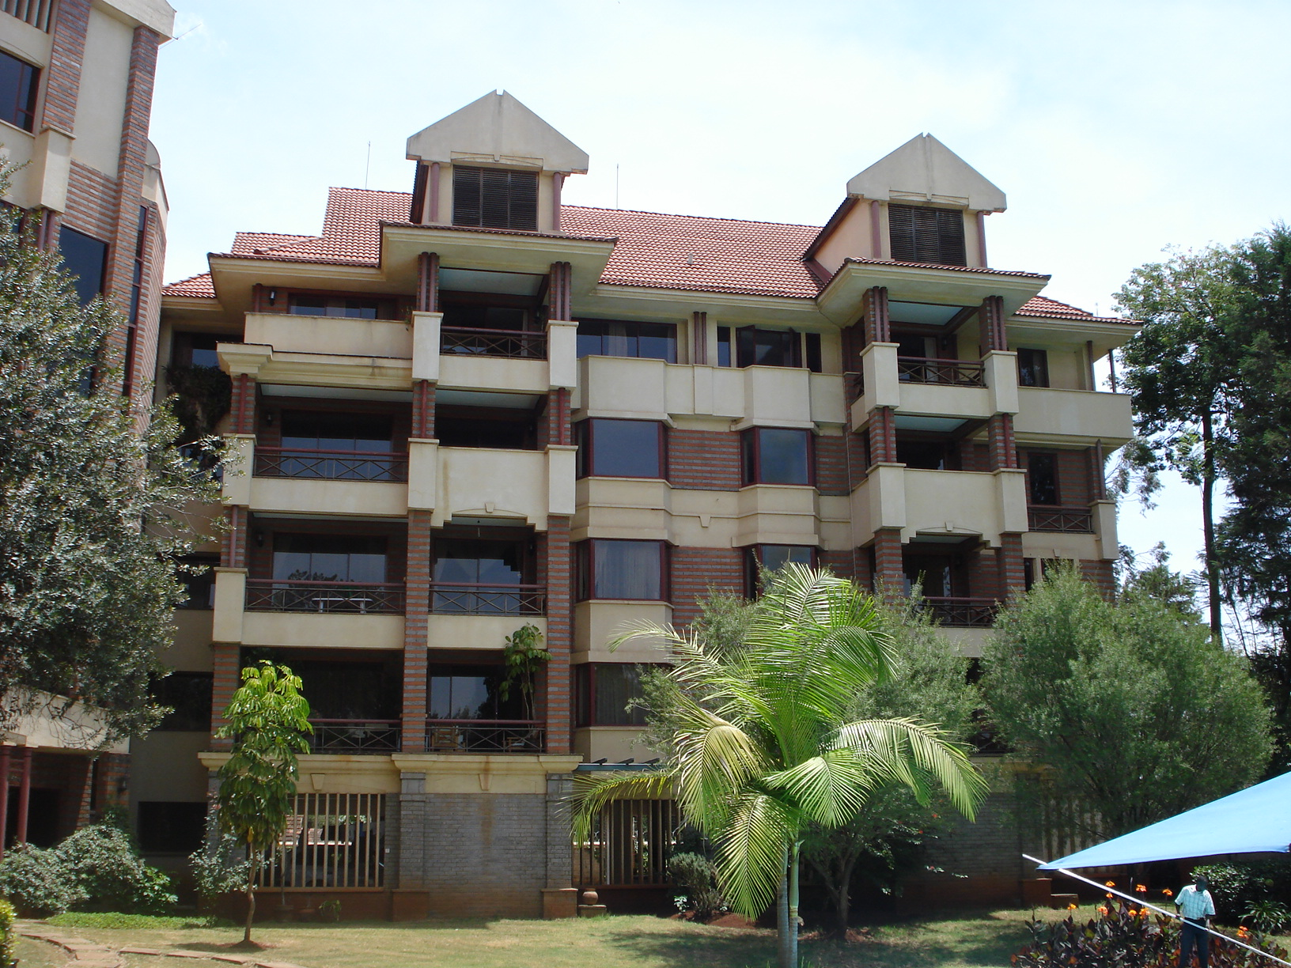
Location: Very spacious apartment, a walking distance from Yaya Centre along Galana road.

Description: 3 bedrooms apartment all ensuite plus a servants quarter.

Features:
- Lounge with a large balcony with sliding doors
- Kitchen with inbuilt cabinets with a granite worktop.
- Dining area
- Guest cloakroom
- Bedroom 1 and 2 No. ensuite with dressing table and inbuilt wadrobes
- Master bedroom with a dressing table, inbuilt wadrobes, bathtub and toilet and a large balcony.
- The floor is wood parquet and ceramic in all wet areas.
- Two parking slots per units
- Well maintained lifts
- Swimming pool
- Sauna

Additional photos
Covered parking
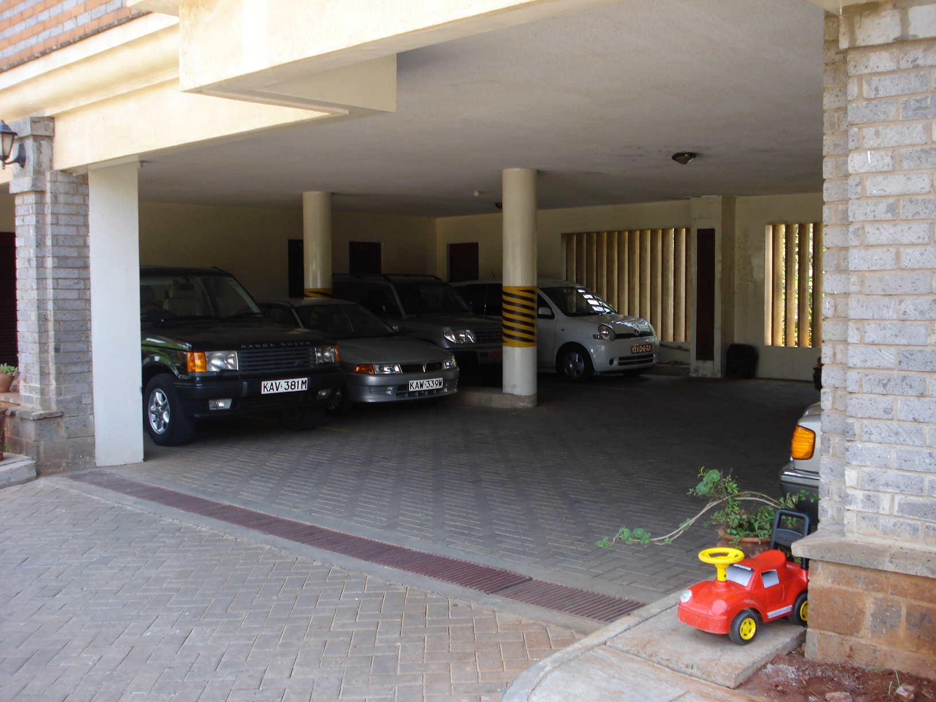
Swimming pool
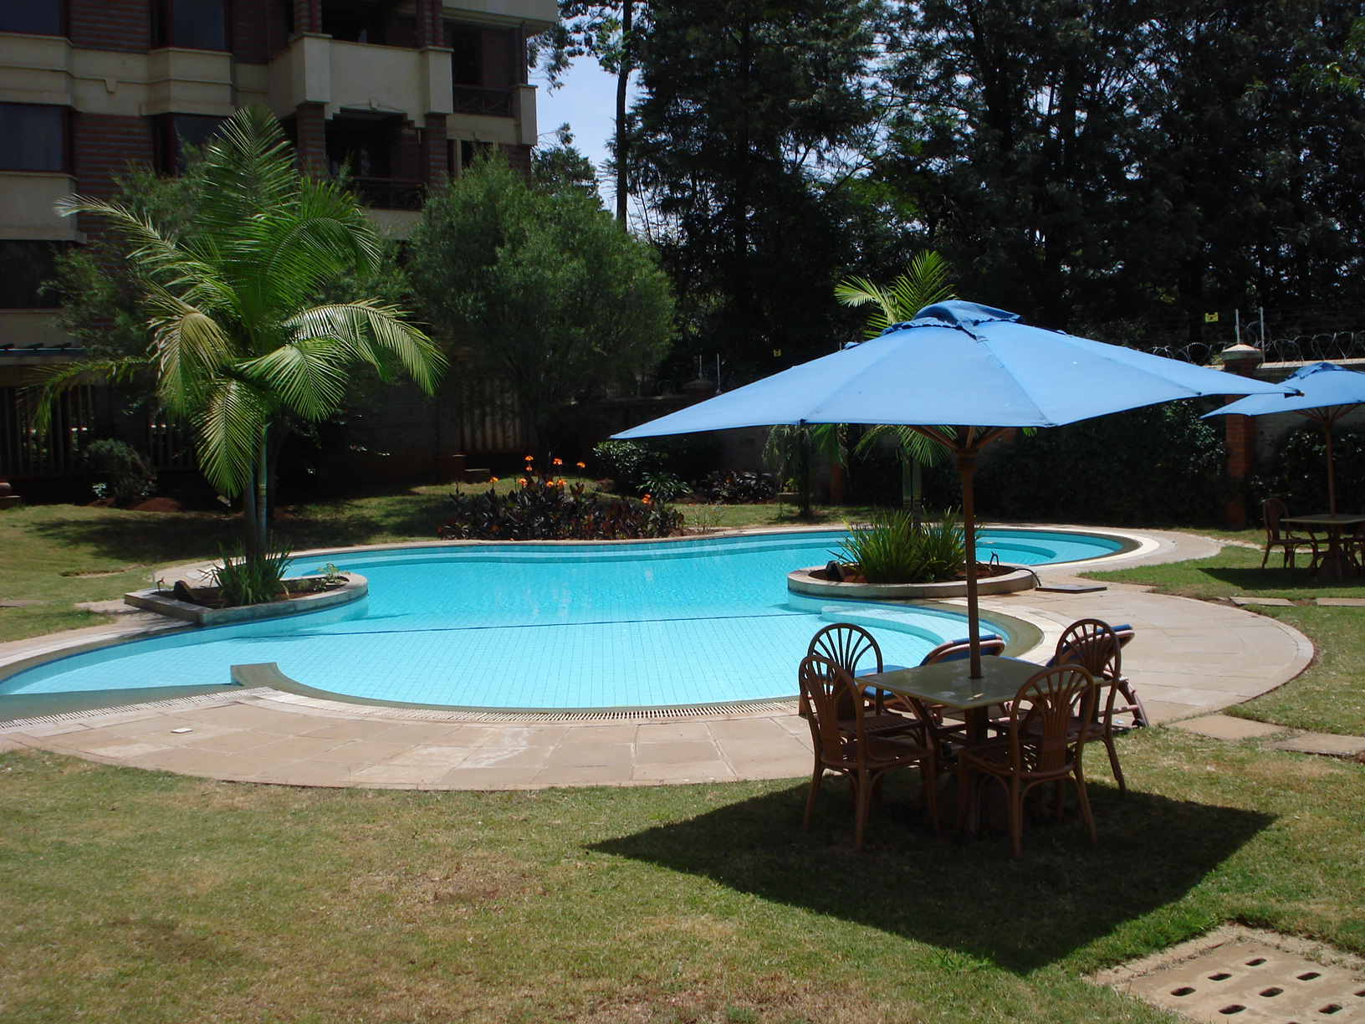

Changing Area
